Regulatory Strategy Report

For

[Device Name]

Manufacturer Name: [Manufacturer name]

Document Number: XXXX

Revision: XXXX

# Revision History

Table 1: History of revision

|  |  |  |
| --- | --- | --- |
| Revision | Date | Change History |
|  |  |  |
|  |  |  |
|  |  |  |
|  |  |  |
|  |  |  |

# Table of Content

Revision History 2

Table of Content 3

Acronyms 4

1. Introduction 5

2. Device description 5

3. Labeling 5

3.1. Intended use 5

3.2. Indication 5

3.3. Targeted patient population 5

3.4. Contra-indications 5

4. EU Regulatory strategy per (EU) 2017/745 6

4.1. Introduction 6

4.2. Product qualification 6

4.2.1. Medical device qualification 6

4.2.2. Qualification of accessory for a medical device 6

4.2.1. Custom-made device qualification 7

4.2.1. Qualification of system or procedure pack 7

4.2.2. Qualification of parts or components 7

4.2.3. Investigational device qualification 8

4.2.4. Qualification of device without an intended medical purpose 8

4.2.5. Qualification of combination product 9

4.3. Device classification 9

4.3.1. Device characteristics 9

4.3.2. Classification rationale 10

4.3.3. Classification conclusion 17

4.4. Conformity assessment route 17

4.4.1. Conformity assessment options 17

4.4.2. Conformity assessment selected 20

4.5. Applicable requirements 20

4.5.1. General requirements 20

4.5.2. Specific requirements 21

# Acronyms

|  |  |
| --- | --- |
| CA | Competent authority |
| EMA | European medicines agency |
| EU | European union |
| GSPR | General safety and performance requirements |
| IVDR | In vitro diagnostic medical devices regulation |
| MDR | Medical devices regulation |
| MDCG | Medical device coordinating group |
| N/A | Not applicable |
| NBOp | Notified body opinion |
| PMCF | Post-market clinical follow-up |
| PMS | Post-market surveillance |
| PSUR | Periodic safety update report |
| UDI | Unique device identification |
| UDI-DI | UDI- Device identifier |
| UDI-PI | UDI-Production identifier |
| WET | Well-established technology |

# Introduction

Include a summary of development status, important information in the development context that are critical for the strategy.

# Device description

Include the description of the product, including the critical elements for the evaluation.

# Labeling

## Intended use

Include the intended use statement or propose a relevant intended use for which the strategy will be based on.

## Indication

Include the indications for use statement or propose relevant indications for which the strategy will be based on.

## Targeted patient population

Remove if not relevant for the evaluation. Include the targeted patient population or propose relevant patient populations for which the strategy will be based on.

## Contra-indications

Remove if not relevant

# EU Regulatory strategy per (EU) 2017/745

## Introduction

Medical devices in Europe are regulated under (EU) 2017/745 (Medical Devices Regulation - MDR) as interpreted by the Medical Device Coordinating Group (MDCG) guidance documents.

Per MDR Article 10(9a), manufacturers need to develop a strategy for regulatory compliance for the devices intended to be marketed in Europe. In addition, Annex II sections 1.1.e and 1.1.f require a manufacturer to provide respectively a rationale that supports the qualification of the product as a device, and the device classification in accordance with Annex VIII.

As a result, this regulatory strategy aims at fulfilling all these objectives and brings a scientific justification for:

* the product qualification (**Section 4.2**)
* the device classification (**Section 4.3**)
* the strategy for regulatory compliance (**Sections 4.4** and **4.5**)

## Product qualification

### Medical device qualification

#### Definition

According to Article 2(1) of the MDR:

*‘medical device’ means any instrument, apparatus, appliance, software, implant, reagent, material or other article intended by the manufacturer to be used, alone or in combination, for human beings for one or more of the following specific medical purposes:*

* *diagnosis, prevention, monitoring, prediction, prognosis, treatment or alleviation of disease,*
* *diagnosis, monitoring, treatment, alleviation of, or compensation for, an injury or disability,*
* *investigation, replacement or modification of the anatomy or of a physiological or pathological process or state,*
* *providing information by means of in vitro examination of specimens derived from the human body, including organ, blood and tissue donations, and which does not achieve its principal intended action by pharmacological, immunological or metabolic means, in or on the human body, but which may be assisted in its function by such means.*

*The following products shall also be deemed to be medical devices:*

* *devices for the control or support of conception;*
* *products specifically intended for the cleaning, disinfection or sterilisation of devices as referred to in Article 1(4) and of those referred to in the first paragraph of this point.*

#### Assessment

Include a solid justification that explains how the product meets the definition.

### Qualification of accessory for a medical device

Section to be removed if the product is already qualified in a category above or if not relevant.

#### Definition

According to Article 2(2) of the MDR:

*‘accessory for a medical device’ means an article which, whilst not being itself a medical device, is intended by its manufacturer to be used together with one or several particular medical device(s) to specifically enable the medical device(s) to be used in accordance with its/their intended purpose(s) or to specifically and directly assist the medical functionality of the medical device(s) in terms of its/their intended purpose(s);*

#### Assessment

Include a solid justification that explains how the product meets the definition.

### Custom-made device qualification

Section to be removed if the product is already qualified in a category above or if not relevant.

#### Definition

According to Article 2(3) of the MDR:

*‘custom-made device’ means any device specifically made in accordance with a written prescription of any person authorised by national law by virtue of that person's professional qualifications which gives, under that person's re sponsibility, specific design characteristics, and is intended for the sole use of a particular patient exclusively to meet their individual conditions and needs.*

*However, mass-produced devices which need to be adapted to meet the specific requirements of any professional user and devices which are mass-produced by means of industrial manufacturing processes in accordance with the written prescriptions of any authorised person shall not be considered to be custom-made devices;*

#### Assessment

Include a solid justification that explains how the product meets the definition.

### Qualification of system or procedure pack

Section to be removed if the product is already qualified in a category above or if not relevant.

#### Definition

According to Articles 2(10) and 2(11) respectively:

*‘procedure pack’ means a combination of products packaged together and placed on the market with the purpose of being used for a specific medical purpose;*

*‘system’ means a combination of products, either packaged together or not, which are intended to be inter- connected or combined to achieve a specific medical purpose;*

#### Assessment

Include a solid justification that explains how the product meets the definition.

### Qualification of parts or components

Section to be removed if the product is already qualified in a category above or if not relevant.

#### Definition

According to Article 23 of the MDR:

*‘Parts and components’ mean item specifically intended to replace an identical or similar integral part or component of a device that is defective or worn in order to maintain or restore the function of the device without changing its performance or safety characteristics or its intended purpose;*

#### Assessment

Include a solid justification that explains how the product meets the definition.

### Investigational device qualification

Section to be removed if the product is already qualified in a category above or if not relevant.

#### Definition

According to Article 2(46) of the MDR:

*‘investigational device’ means a device that is assessed in a clinical investigation;*

#### Assessment

Include a solid justification that explains how the product meets the definition.

### Qualification of device without an intended medical purpose

Section to be removed if the product is already qualified in a category above or if not relevant.

#### Definition

Products qualified as devices without an intended medical purpose, are the products that do not meet one of the medical purposes of the medical device definition (see **Section 4.2.1**) and are included into one of the categories defined in Annex XVI of the MDR:

1. *Contact lenses or other items intended to be introduced into or onto the eye.*
2. *Products intended to be totally or partially introduced into the human body through surgically invasive means for the purpose of modifying the anatomy or fixation of body parts with the exception of tattooing products and piercings.*
3. *Substances, combinations of substances, or items intended to be used for facial or other dermal or mucous membrane filling by subcutaneous, submucous or intradermal injection or other introduction, excluding those for tattooing.*
4. *Equipment intended to be used to reduce, remove or destroy adipose tissue, such as equipment for liposuction, lipolysis or lipoplasty.*
5. *High intensity electromagnetic radiation (e.g. infra-red, visible light and ultra-violet) emitting equipment intended for use on the human body, including coherent and non-coherent sources, monochromatic and broad spectrum, such as lasers and intense pulsed light equipment, for skin resurfacing, tattoo or hair removal or other skin treatment.*
6. *Equipment intended for brain stimulation that apply electrical currents or magnetic or electromagnetic fields that penetrate the cranium to modify neuronal activity in the brain.*

#### Assessment

Include a solid justification that explains how the product meets the definition.

### Qualification of combination product

Section to be removed if the product is already qualified in a category above or if not relevant.

#### Definition

According to Article 1(8) of the MDR:

*Any device which, when placed on the market or put into service, incorporates, as an integral part, a substance which, if used separately, would be considered to be a medicinal product as defined in point 2 of Article 1 of Directive 2001/83/EC, including a medicinal product derived from human blood or human plasma as defined in point 10 of Article 1 of that Directive, and that has an action ancillary to that of the device, shall be assessed and authorised in accordance with this Regulation.*

*However, if the action of that substance is principal and not ancillary to that of the device, the integral product shall be governed by Directive 2001/83/EC or Regulation (EC) No 726/2004 of the European Parliament and of the Council (1), as applicable. In that case, the relevant general safety and performance requirements set out in Annex I to this Regulation shall apply as far as the safety and performance of the device part are concerned.*

According to Article 1(9) of the MDR:

*Any device which is intended to administer a medicinal product as defined in point 2 of Article 1 of Directive 2001/83/EC shall be governed by this Regulation, without prejudice to the provisions of that Directive and of Regulation (EC) No 726/2004 with regard to the medicinal product.*

*However, if the device intended to administer a medicinal product and the medicinal product are placed on the market in such a way that they form a single integral product which is intended exclusively for use in the given combination and which is not reusable, that single integral product shall be governed by Directive 2001/83/EC or Regulation (EC) No 726/2004, as applicable. In that case, the relevant general safety and performance requirements set out in Annex I to this Regulation shall apply as far as the safety and performance of the device part of the single integral product are concerned.*

#### Assessment

Include a solid justification that explains how the product meets the definition.

## Device classification

The device classification is defined per Annex VIII of the MDR and based on the following guidance documents:

* To be removed when not relevant
* MDCG 2019-11 - Qualification and classification of software - Regulation (EU) 2017/745 and Regulation (EU) 2017/746
* MDCG 2021-24 - Guidance on classification of medical devices
* MDCG 2022-5 - Guidance on borderline between medical devices and medicinal products under Regulation (EU) 2017/745 on medical devices
* Manual on borderline and classification under Regulations (EU) 2017/745 and 2017/746

### Device characteristics

MDR and applicable MDCG guidance documents describe the device characteristics necessary to determine the classification and regulatory route of conformity.

Table 2: Justification of device characteristics

| **Type of characteristics** | **Description of characteristics** | **Justifications** |
| --- | --- | --- |
| Duration of use | Tick the box via “◼”  ◻ Transient  ◻ Short term  ◻ Long term  ◻ Implantable |  |
| Invasive device | ◻ Non-invasive device  ◻ Surgically invasive device  ◻ Invasive device via body orifice  ◻ Reusable surgical instrument |  |
| Active device | ◻ Non-active device  ◻ Active device  ◻ Active therapeutic device  ◻ Active device intended for diagnosis and monitoring  ◻ Software |  |
| WET | ◻ Yes, the device is part of the list in Article 52.4 and the WET is confirmed by the state of the art of similar devices.  ◻ No | Devices covered by Article 52.4: sutures, staples, dental fillings, dental braces, tooth crowns, screws, wedges, plates, wires, pins, clips and connectors.  A comparison with similar devices is required with consideration of criteria (1 to 3) from MDCG 2020-6. |

### Classification rationale

The following table represents the justification of device classification for [Device short name].

Table 3: Classification rationale

| **Rule** | **Rule description** | **Rationale of classification** |
| --- | --- | --- |
| **Non-invasive devices** | | |
| Rule 1 | All non-invasive devices are classified as class I, unless one of the rules set out hereinafter applies. |  |
| Rule 2 | All non-invasive devices intended for channelling or storing blood, body liquids, cells or tissues, liquids or gases for the purpose of eventual infusion, administration or introduction into the body are classified as class IIa:  — if they may be connected to a class IIa, class IIb or class III active device; or  — if they are intended for use for channelling or storing blood or other body liquids or for storing organs, parts of organs or body cells and tissues, except for blood bags; blood bags are classified as class IIb.  In all other cases, such devices are classified as class I. |  |
| Rule 3 | All non-invasive devices intended for modifying the biological or chemical composition of human tissues or cells, blood, other body liquids or other liquids intended for implantation or administration into the body are classified as class IIb, unless the treatment for which the device is used consists of filtration, centrifugation or exchanges of gas, heat, in which case they are classified as class IIa.  All non-invasive devices consisting of a substance or a mixture of substances intended to be used in vitro in direct contact with human cells, tissues or organs taken from the human body or used in vitro with human embryos before their implantation or administration into the body are classified as class III. |  |
| Rule 4 | All non-invasive devices which come into contact with injured skin or mucous membrane are classified as:  — class I if they are intended to be used as a mechanical barrier, for compression or for absorption of exudates;  — class IIb if they are intended to be used principally for injuries to skin which have breached the dermis or mucous membrane and can only heal by secondary intent;  — class IIa if they are principally intended to manage the micro-environment of injured skin or mucous membrane; and  — class IIa in all other cases.  This rule applies also to the invasive devices that come into contact with injured mucous membrane. |  |
| **Invasive devices** | | |
| Rule 5 | All invasive devices with respect to body orifices, other than surgically invasive devices, which are not intended for connection to an active device or which are intended for connection to a class I active device are classified as:  — class I if they are intended for transient use;  — class IIa if they are intended for short-term use, except if they are used in the oral cavity as far as the pharynx, in an ear canal up to the ear drum or in the nasal cavity, in which case they are classified as class I; and  — class IIb if they are intended for long-term use, except if they are used in the oral cavity as far as the pharynx, in an ear canal up to the ear drum or in the nasal cavity and are not liable to be absorbed by the mucous membrane, in which case they are classified as class IIa.  All invasive devices with respect to body orifices, other than surgically invasive devices, intended for connection to a class IIa, class IIb or class III active device, are classified as class IIa. |  |
| Rule 6 | All surgically invasive devices intended for transient use are classified as class IIa unless they:  — are intended specifically to control, diagnose, monitor or correct a defect of the heart or of the central circulatory system through direct contact with those parts of the body, in which case they are classified as class III;  — are reusable surgical instruments, in which case they are classified as class I;  — are intended specifically for use in direct contact with the heart or central circulatory system or the central nervous system, in which case they are classified as class III;  — are intended to supply energy in the form of ionising radiation in which case they are classified as class IIb;  — have a biological effect or are wholly or mainly absorbed in which case they are classified as class IIb; or  — are intended to administer medicinal products by means of a delivery system, if such administration of a medicinal product is done in a manner that is potentially hazardous taking account of the mode of application, in which case they are classified as class IIb. |  |
| Rule 7 | All surgically invasive devices intended for short-term use are classified as class IIa unless they:  — are intended specifically to control, diagnose, monitor or correct a defect of the heart or of the central circulatory system through direct contact with those parts of the body, in which case they are classified as class III;  — are intended specifically for use in direct contact with the heart or central circulatory system or the central nervous system, in which case they are classified as class III;  — are intended to supply energy in the form of ionizing radiation in which case they are classified as class IIb;  — have a biological effect or are wholly or mainly absorbed in which case they are classified as class III;  — are intended to undergo chemical change in the body in which case they are classified as class IIb, except if the devices are placed in the teeth; or  — are intended to administer medicines, in which case they are classified as class IIb. |  |
| Rule 8 | All implantable devices and long-term surgically invasive devices are classified as class IIb unless they:  — are intended to be placed in the teeth, in which case they are classified as class IIa;  — are intended to be used in direct contact with the heart, the central circulatory system or the central nervous system, in which case they are classified as class III;  — have a biological effect or are wholly or mainly absorbed, in which case they are classified as class III;  — are intended to undergo chemical change in the body in which case they are classified as class III, except if the devices are placed in the teeth;  — are intended to administer medicinal products, in which case they are classified as class III;  — are active implantable devices or their accessories, in which cases they are classified as class III;  — are breast implants or surgical meshes, in which cases they are classified as class III;  — are total or partial joint replacements, in which case they are classified as class III, with the exception of ancillary components such as screws, wedges, plates and instruments; or  — are spinal disc replacement implants or are implantable devices that come into contact with the spinal column, in which case they are classified as class III with the exception of components such as screws, wedges, plates and instruments. |  |
| Rule 9 | All active therapeutic devices intended to administer or exchange energy are classified as class IIa unless their characteristics are such that they may administer energy to or exchange energy with the human body in a potentially hazardous way, taking account of the nature, the density and site of application of the energy, in which case they are classified as class IIb.  All active devices intended to control or monitor the performance of active therapeutic class IIb devices, or intended directly to influence the performance of such devices are classified as class IIb.  All active devices intended to emit ionizing radiation for therapeutic purposes, including devices which control or monitor such devices, or which directly influence their performance, are classified as class IIb.  All active devices that are intended for controlling, monitoring or directly influencing the performance of active implantable devices are classified as class III. |  |
| Rule 10 | Active devices intended for diagnosis and monitoring are classified as class IIa:  — if they are intended to supply energy which will be absorbed by the human body, except for devices intended to illuminate the patient's body, in the visible spectrum, in which case they are classified as class I;  — if they are intended to image in vivo distribution of radiopharmaceuticals; or  — if they are intended to allow direct diagnosis or monitoring of vital physiological processes, unless they are specifically intended for monitoring of vital physiological parameters and the nature of variations of those parameters is such that it could result in immediate danger to the patient, for instance variations in cardiac performance, respiration, activity of the central nervous system, or they are intended for diagnosis in clinical situations where the patient is in immediate danger, in which cases they are classified as class IIb.  Active devices intended to emit ionizing radiation and intended for diagnostic or therapeutic radiology, including interventional radiology devices and devices which control or monitor such devices, or which directly influence their performance, are classified as class IIb. |  |
| Rule 11 | Software intended to provide information which is used to take decisions with diagnosis or therapeutic purposes is classified as class IIa, except if such decisions have an impact that may cause:  — death or an irreversible deterioration of a person's state of health, in which case it is in class III; or  — a serious deterioration of a person's state of health or a surgical intervention, in which case it is classified as class IIb.  Software intended to monitor physiological processes is classified as class IIa, except if it is intended for monitoring of vital physiological parameters, where the nature of variations of those parameters is such that it could result in immediate danger to the patient, in which case it is classified as class IIb.  All other software is classified as class I. |  |
| Rule 12 | All active devices intended to administer and/or remove medicinal products, body liquids or other substances to or from the body are classified as class IIa, unless this is done in a manner that is potentially hazardous, taking account of the nature of the substances involved, of the part of the body concerned and of the mode of application in which case they are classified as class IIb. |  |
| Rule 13 | All other active devices are classified as class I. |  |
| **Special rules** | | |
| Rule 14 | All devices incorporating, as an integral part, a substance which, if used separately, can be considered to be a medicinal product, as defined in point 2 of Article 1 of Directive 2001/83/EC, including a medicinal product derived from human blood or human plasma, as defined in point 10 of Article 1 of that Directive, and that has an action ancillary to that of the devices, are classified as class III. |  |
| Rule 15 | All devices used for contraception or prevention of the transmission of sexually transmitted diseases are classified as class IIb, unless they are implantable or long term invasive devices, in which case they are classified as class III. |  |
| Rule 16 | All devices intended specifically to be used for disinfecting, cleaning, rinsing or, where appropriate, hydrating contact lenses are classified as class IIb.  All devices intended specifically to be used for disinfecting or sterilising medical devices are classified as class IIa, unless they are disinfecting solutions or washer-disinfectors intended specifically to be used for disinfecting invasive devices, as the end point of processing, in which case they are classified as class IIb.  This rule does not apply to devices that are intended to clean devices other than contact lenses by means of physical action only. |  |
| Rule 17 | Devices specifically intended for recording of diagnostic images generated by X-ray radiation are classified as class IIa. |  |
| Rule 18 | All devices manufactured utilising tissues or cells of human or animal origin, or their derivatives, which are non- viable or rendered non-viable, are classified as class III, unless such devices are manufactured utilising tissues or cells of animal origin, or their derivatives, which are non-viable or rendered non-viable and are devices intended to come into contact with intact skin only. |  |
| Rule 19 | All devices incorporating or consisting of nanomaterial are classified as:  — class III if they present a high or medium potential for internal exposure;  — class IIb if they present a low potential for internal exposure; and  — class IIa if they present a negligible potential for internal exposure. |  |
| Rule 20 | All invasive devices with respect to body orifices, other than surgically invasive devices, which are intended to administer medicinal products by inhalation are classified as class IIa, unless their mode of action has an essential impact on the efficacy and safety of the administered medicinal product or they are intended to treat life- threatening conditions, in which case they are classified as class IIb. |  |
| Rule 21 | Devices that are composed of substances or of combinations of substances that are intended to be introduced into the human body via a body orifice or applied to the skin and that are absorbed by or locally dispersed in the human body are classified as:  — class III if they, or their products of metabolism, are systemically absorbed by the human body in order to achieve the intended purpose;  — class III if they achieve their intended purpose in the stomach or lower gastrointestinal tract and they, or their products of metabolism, are systemically absorbed by the human body;  — class IIa if they are applied to the skin or if they are applied in the nasal or oral cavity as far as the pharynx, and achieve their intended purpose on those cavities; and  — class IIb in all other cases. |  |
| Rule 22 | Active therapeutic devices with an integrated or incorporated diagnostic function which significantly determines the patient management by the device, such as closed loop systems or automated external defibrillators, are classified as class III. |  |

To be removed if the device is not class I/ As the device has been determined to be class I under Annex VIII of the MDR, MDCG 2021-24 been considered to evaluate if [Device short name] is considered a reusable surgical instrument, has a measuring function, or is sterile.

As described **section 4.3.1**, the device meets /does not meet the definition of reusable surgical instrument, hence [device short name] is / is not class Ir. In addition, as the device is / is not marketed “sterile” by the manufacturer, [device short name] is / is not class Is. Finally, per MDCG 2021-24 section 3.1.6, the device fulfils / does not fulfil the following criteria together as justified in **Table 4**. [Device short name] is/ is not class Im.

Table 4: Criteria of measuring function for class I devices

| **Criteria** | **Justification** | **Applicable** |
| --- | --- | --- |
| a) The device is intended by the manufacturer to measure | - | - |
| * quantitatively a physiological or anatomical parameter, or |  | Yes/No |
| * a quantity or a quantifiable characteristic of energy or of substances (including medicinal products) delivered to or removed from the human body. Spoons or plastic syringes co-packed with medicinal products and used to measure a quantity of that medicinal product to be administered to the patient are in this category. Devices for the delivery of liquid to the human body without graduation or scale (e.g. medicine spoons, cups, droppers without graduation or scale or display of measuring unit) are not in this category |  | Yes/No |
| b) The result of the measurement: | - | - |
| * is displayed in legal units or other acceptable units within the meaning of Directive 80/181/ECC20, or |  | Yes/No |
| * is compared to at least one point of reference indicated in legal units or other acceptable units in compliance with the mentioned directive |  | Yes/No |
| c) The intended purpose implies accuracy, claimed explicitly or implicitly, where a non-compliance with the implied accuracy could result in a significant adverse effect on the patient’s health and safety. |  | Yes/No |

### Classification conclusion

[device short name] has been determined to be:

* Class XX per Rule Y
* Class XX per Rule Y

According to Annex VIII section 3.5, If several rules, or if, within the same rule, several sub-rules, apply to the same device based on the device's intended purpose, the strictest rule and sub-rule resulting in the higher classification shall apply.

In conclusion, [device short name] is class XX per Rule Y.

## Conformity assessment route

### Conformity assessment options

[Device short name] has been determined to be class III/IIb/IIa/Im/Ir/Is/I under Annex VIII of the MDR. Hence, [Device short name] can be marketed in EU using one of the regulatory pathways, described in the following flowchart.

Remove the flowcharts that are not applicable.

Figure 1: Applicable regulatory routes for Class X devices under MDR.

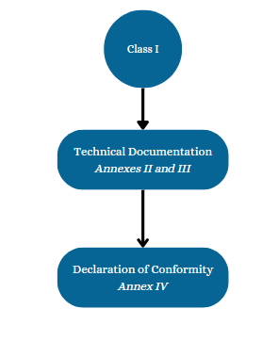

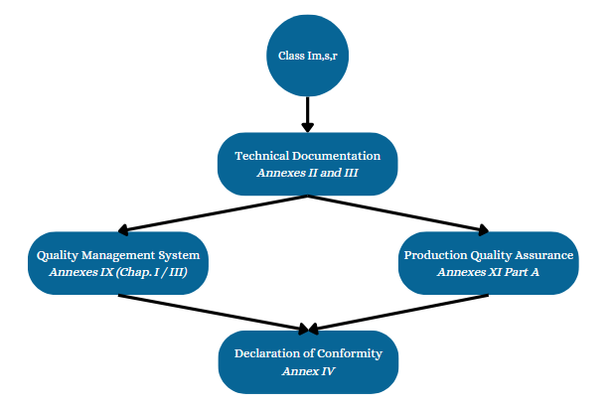

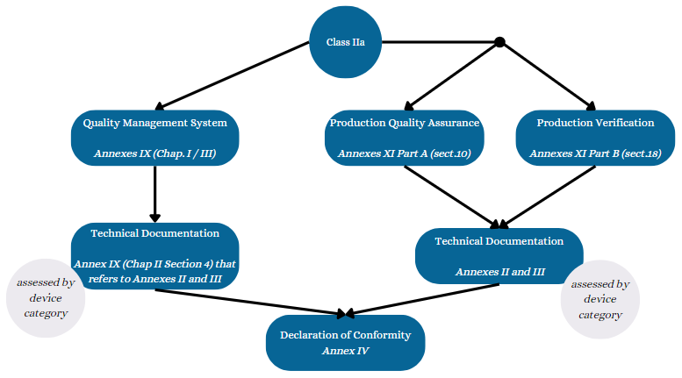

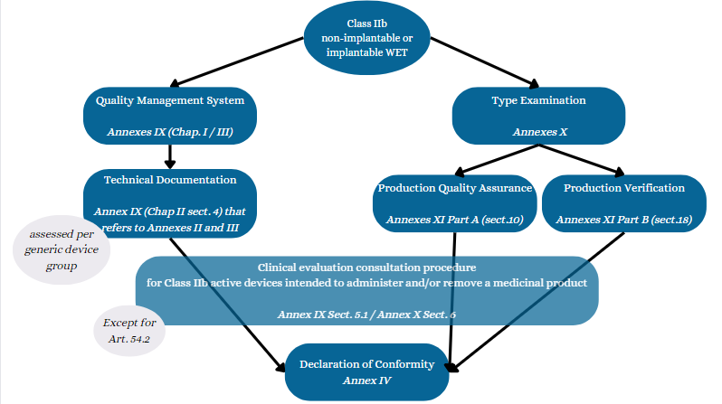

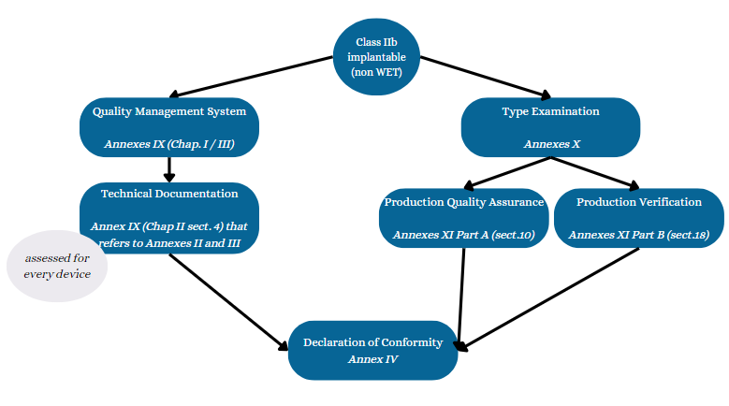

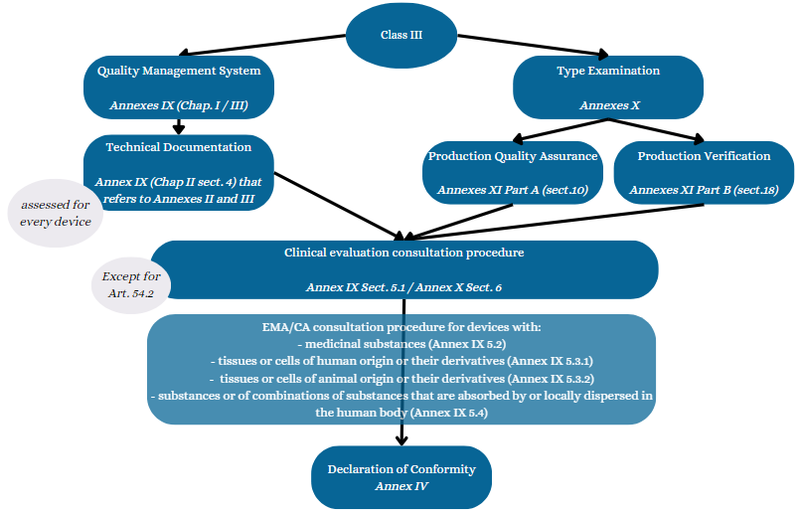

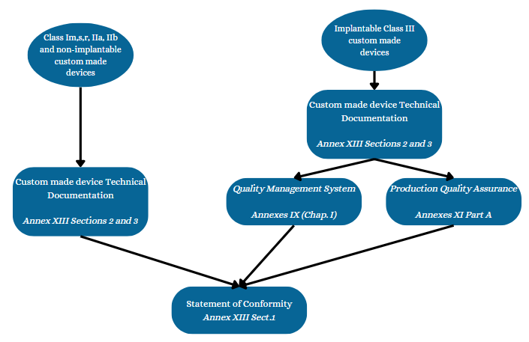

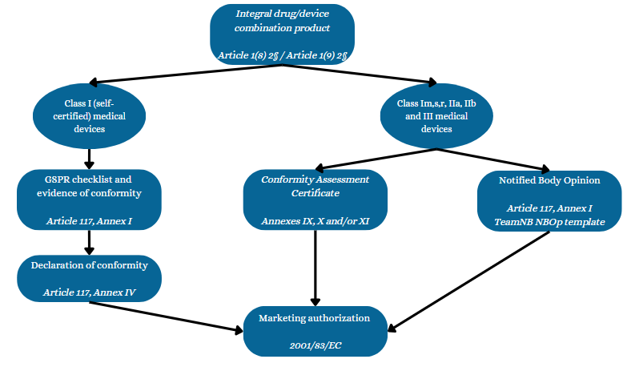

### Conformity assessment selected

The regulatory route selected by [Manufacturer name] is:

* Describe the Annex(es)/article(s) of the MDR selected as defined in the flowchart above.

## Applicable requirements

### General requirements

Considering the device type, intended use, classification and selected conformity assessment procedure, the following MDR requirements are applicable.

Table 5: Applicable MDR requirements

| **Type of requirements** | **Description** | **Comments and justifications** |
| --- | --- | --- |
| Notified Body Involvement | Tick the box via “◼”  ◻ Yes  ◻ No | Provide sufficient details to explain how the requirement is applicable or not applicable; provide the justification for the transitional provisions from MDD to MDR (if applicable); justify when the requirement will enter into force (if applicable); etc. |
| Quality management system | ◻ Yes, per MDR Article 10(9)  ◻ Yes, per EN ISO 13485  ◻ Other  ◻ N/A |  |
| Authorized representative | ◻ Yes, per Articles 11 and 12  ◻ N/A |  |
| Person Responsible for Regulatory Compliance | ◻ Yes, per Article 15  ◻ N/A |  |
| Declaration of conformity | ◻ Yes, per Article 19 and Annex IV  ◻ Yes, per Annex XIII  ◻ N/A |  |
| CE marking | ◻ Yes, per Article 20 and Annex V  ◻ N/A |  |
| Technical documentation | ◻ Yes, per Annexes II and III  ◻ Yes, per Annex XIII  ◻ N/A |  |
| Notified Body Opinion | ◻ Yes, per Article 117  ◻ N/A |  |
| Consultation procedure with EMA or CA | ◻ Yes, the device includes a medicinal substance (Annex IX 5.2)  ◻ Yes, the device includes tissues or cells of human/animal origin and their derivatives (Annex IX 5.3)  ◻ Yes, the device includes substances absorbed by or locally dispersed in the human body (Annex IX 5.4)  ◻ N/A |  |
| Clinical evaluation | ◻ Yes, per Article 61 and Annex XIV  ◻ N/A |  |
| Summary of safety and clinica performance | ◻ Yes, per Article 32  ◻ N/A |  |
| Expert panel review | ◻ Yes, per Article 54  ◻ No, within exemptions from Article 54.2  ◻ N/A |  |
| Implant card | ◻ Yes, per Article 18  ◻ N/A |  |
| Post-market surveillance (PMS) activities | ◻ Yes, per Articles 83 to 86 and Annex III  ◻ N/A |  |
| Post-market clinical follow-up (PMCF) activities | ◻ Yes, per Article 61 and Annex XIV  ◻ N/A |  |
| UDI carrier | ◻ Yes, per Annex VI Part C  ◻ Yes, but applicable from YYYY/MM/DD per Article 123  ◻ N/A |  |
| Basic UDI-DI, UDI-DI/PI | ◻ Yes, per Article 27 and Annex VI  ◻ N/A |  |
| Economic operator registration | ◻ Yes, per Articles 30, 31, 120 and Annex VI  ◻ N/A |  |
| Device registration | ◻ Yes, per Articles 29, 120 and Annex VI  ◻ N/A |  |
| Transitional provisions for legacy device | ◻ Yes, per article 120  ◻ N/A, the product is not a legacy device |  |
| Other |  |  |

### Specific requirements

This section is optional but can be useful when a project starts.

Requirements specific to [Device short name] have been looked for and the following has been determined applicable.

Table 6: Applicable MDR requirements

| **Reference** | **Title** | **Comment** |
| --- | --- | --- |
| **MDCG guidance documents**  Check the applicable MDCG guidance documents via the following [website](https://health.ec.europa.eu/medical-devices-sector/new-regulations/guidance-mdcg-endorsed-documents-and-other-guidance_en). | | |
| MDCG 2020-2 rev.1 | Class I transitional provisions under Article 120 (3 and 4) – (MDR) | Applicable to class I only |
| MDCG 2019-15 rev.1 | Guidance notes for manufacturers of class I medical devices | Applicable to class I only |
| MDCG 2020-7 | Guidance on PMCF plan template | Applicable to all devices |
| MDCG 2020-8 | Guidance on PMCF evaluation report template | Applicable to all devices |
| MDCG 2022-21 | Guidance on Periodic Safety Update Report (PSUR) according to Regulation (EU) 2017/745 | Applicable to all devices |
| MDCG 2020-6 | Guidance on sufficient clinical evidence for legacy devices | Applicable to all devices |
| MDCG 2020-5 | Guidance on clinical evaluation – Equivalence | Applicable when an equivalence route is used in the CER |
| MDCG 2019-9 - Rev.1 | Summary of safety and clinical performance | Applicable to class III and implantable devices |
| MDCG 2021-3 | Questions and Answers on Custom-Made Devices | Applicable to custom made devices |
| MDCG 2021-11 | Guidance on Implant Card – Device types | Applicable to implants |
| MDCG 2019-8 v2 | Guidance document implant card on the application of Article 18 Regulation (EU) 2017/745 on medical devices | Applicable to implants |
| MDCG 2020-1 | Guidance on clinical evaluation (MDR) / Performance evaluation (IVDR) of medical device software | Applicable to devices with software |
| MDCG 2019-16 rev.1 | Guidance on cybersecurity for medical devices | Applicable to devices with software |
| XXX | XXX |  |
| **Harmonized standards**  Consult the lists of harmonized standards via the following [website](https://health.ec.europa.eu/medical-devices-topics-interest/harmonised-standards_en) | | |
| EN ISO 10993-23:2021 | Biological evaluation of medical devices - Part 23: Tests for irritation [1] | Biocompatibility |
| EN ISO 11135:2014/A1:2019 | Sterilization of health care products - Ethylene oxide - Requirements for the development, validation and routine control of a sterilization process for medical devices [2] | Sterilization |
| EN ISO 11137-1:2015/A2:2019 | Sterilization of health care products - Radiation - Part 1: Requirements for development, validation and routine control of a sterilization process for medical devices [3] | Sterilization |
| EN ISO 11737-2:2020 | Sterilization of health care products - Microbiological methods - Part 2: Tests of sterility performed in the definition, validation and maintenance of a sterilization process [4] | Sterilization |
| 25424:2019/A1:2022 | Sterilisation of health care products – Low temperature steam and formaldehyde – Requirements for development, validation and routine control of a sterilisation process for medical devices [5] | Sterilization |
| EN ISO 10993-9:2021 | Biological evaluation of medical devices - Part 9: Framework for identification and quantification of potential degradation products [6] | Biocompatibility |
| EN ISO 10993-12:2021 | Biological evaluation of medical devices - Part 12: Sample preparation and reference materials [7} | Biocompatibility |
| EN ISO 11737-1:2018 | Sterilization of health care products - Microbiological methods - Part 1: Determination of a population of microorganisms on products [8] | Sterilization |
| EN ISO 13408-6:2021 | Aseptic processing of health care products - Part 6: Isolator systems [9] | Sterilization |
| EN ISO 13485:2016/A11:2021 | Medical devices – Quality management systems – Requirements for regulatory purposes [10] | Quality management system |
| EN ISO 14160:2021 | Sterilization of health care products - Liquid chemical sterilizing agents for single-use medical devices utilizing animal tissues and their derivatives - Requirements for characterization, development, validation and routine control of a sterilization process for medical devices [11] | Sterilization |
| EN ISO 15223-1:2021 | Medical devices - Symbols to be used with information to be supplied by the manufacturer - Part 1: General requirements [12] | Labeling |
| EN ISO 17664-1:2021 | Processing of health care products - Information to be provided by the medical device manufacturer for the processing of medical devices - Part 1: Critical and semi-critical medical devices [13] | Labeling |
| EN IEC 60601-2-83:2020/A11:2021 | Medical electrical equipment - Part 2-83: Particular requirements for the basic safety and essential performance of home light therapy equipment [14] | Electrical equipment |
| EN 285:2015+A1:2021 | Sterilization – Steam sterilizers – Large sterilizers [15] | Sterilization |
| EN ISO 14971:2019/A11:2021 | Medical devices – Application of risk management to medical devices [16] | Risk management |
| EN ISO 10993-10:2023 | Biological evaluation of medical devices – Part 10: Tests for skin sensitization [17] | Biocompatibility |
| **State of the art standards**  List additional standards relevant to the device that represent the state of the art (e.g. other biocompatibility standards, usability standards, etc.) | | |
| XXX | XXX |  |