**PMS Plan**

For

[Device Name]

Manufacturer Name: [Manufacturer name]

Document Number: XXXX

Revision: XXXX

# Approval

**Reviewer**

|  |  |
| --- | --- |
|  | |
| Name: | Date: |
| Title: | Signature: |

**Approver**

|  |  |
| --- | --- |
|  | |
| Name: | Date: |
| Title: | Signature: |
|  | |
| Name: | Date: |
| Title: | Signature: |

# Revision history

Table 1: History of revisions

| **Revision** | **Revision date** | **Description of change** | **Revised by** |
| --- | --- | --- | --- |
|  |  |  |  |
|  |  |  |  |
|  |  |  |  |

# Scope

The PMS plan covers the following device range(s): [Device name 1], [Device name 2], hereafter named under [device short name].

The PMS plan covers the period from DD Month YYYY to DD Month YYYY.

This PMS plan has been defined in compliance with Article 84 and Annex XIV of the (EU) 2017/745 (MDR) as well as the guidance document MDCG 2022-21.

# PMS general details

The following table includes the general details related to PMS activities.

Table 2: PMS general information

|  |  |  |  |
| --- | --- | --- | --- |
| **1** | **Manufacturer information** | | |
| **a** | Manufacturer SRN: XXX | | |
| **b** | Manufacturer organization name: XXX | | |
| **c** | Contact’s first name: XXX | **e** | Contact’s last name: XXX |
| **d** | Email: XXX | **f** | Phone: XXX |
| **g** | Country: XXX | | |
| **h** | Street: XXX | **i** | Street number: XXX |
| **j** | Address complement: XXX | **k** | PO box: XXX |
| **l** | City name: XXX | **m** | Postal code: XXX |
| **2** | **Authorized representative information** | | |
| **a** | SRN: XXX | | |
| **b** | Authorized representative organization name: XXX | | |
| **c** | Contact’s first name: XXX | **e** | Contact’s last name: XXX |
| **d** | Email: XXX | **f** | Phone: XXX |
| **g** | Country: XXX | | |
| **h** | Street: XXX | **i** | Street number: XXX |
| **j** | Address complement: XXX | **k** | PO box: XXX |
| **l** | City name: XXX | **m** | Postal code: XXX |
| **3** | **Corresponding competent authority** | | |
| **a** | Name of National Competent Authority (NCA): XXX | | |
| **b** | EUDAMED number of NCA: XXX | | |
| **4** | **Notified Body** | | |
| **a** | NB organization name: XXX  NB number: XXX | | |
| **b** | Email: XXX | | |
| **5** | **Medical device information** | | |
| **a** | Leading device Basic UDI-DI / Eudamed DI(s) : XXX | | |
| **b** | Other Basic UDI-DI(s) / Eudamed DI(s): XXX (See Appendix I) /OR See below | | |
| **c** | For each Basic UDI-DI / Eudamed DI, NB number and Certificate ID(s): XXX (See Appendix I) / OR   |  |  |  | | --- | --- | --- | | **Basic UDI-DI(s) / Eudamed DI(s)** | **NB Number** | **Certificate ID** | |  |  |  | |  |  |  | |  |  |  | | | |

# Medical devices information

## General device information

General regulatory information of devices covered by the PMS plan are described in **Appendix I – Devices in scope of PMS plan.**

The following table summarizes the marketing and regulatory status of devices in Europe.

Table 3: Device status in Europe

|  |  |  |  |  |  |
| --- | --- | --- | --- | --- | --- |
| **Trade Name** | **Class** | **EU regulatory history (Date)** | | **Status** | |
| **First DoC** | **First EU/EC certificate** | **Marketed in EU?** | **FSCA?** |
| ***Leading device*** | | | | | |
| [Device Name 1] | XX | DD-Mon-YYYY | DD-Mon-YYYY | on the market / no longer placed on the market | No ongoing FSCA /  Recalled / field safety corrective action |
| ***Other devices*** | | | | | |
| [Device Name 2] |  |  |  |  |  |
| [Device Name 3] |  |  |  |  |  |
| [Device Name 4] |  |  |  |  |  |
| [Device Name 5] |  |  |  |  |  |

## Grouping justification

Using the principles of MDCG 2022-21 coupled with the sampling methods of notified body described in MDCG 2019-13, [manufacturer name] reached the conclusion that grouping of devices described in **Appendix I – Devices in scope of PMS plan**, is appropriate for the following reasons:

Include a justification for the grouping of device with factual evidence and justify the benefits to report multiple devices in one PSUR or alternatively the disadvantages to report each device in separate PSURs.

Considering the characteristics of devices presented in **Appendix I – Devices in scope of PMS plan,** the leading device has been selected with the highest classification and highest expected lifetime and is XXX. The leading device will drive the schedule of the PSUR such as data collection period covered, PSUR frequency, issuance timeline, PSUR reporting through EUDAMED, irrespective of the certification dates and classes of other devices.

The principal milestones for the schedule of the PSUR are described in **Section 9**.

## Labelling information

### Leading device: [Device Name 1]

#### Intended purpose

*Indicate the intended purpose as reported in the IFU*

#### Indications for use

*Indicate the intended purpose as reported in the IFU*

#### Contra-indications

*Indicate the intended purpose as reported in the IFU*

#### Target populations

*Indicate the intended purpose as reported in the IFU*

### [Device Name 2]

#### Intended purpose

*Indicate the intended purpose as reported in the IFU*

#### Indications for use

*Indicate the intended purpose as reported in the IFU*

#### Contra-indications

*Indicate the intended purpose as reported in the IFU*

#### Target populations

*Indicate the intended purpose as reported in the IFU*

### [Device Name 3]

#### Intended purpose

*Indicate the intended purpose as reported in the IFU*

#### Indications for use

*Indicate the intended purpose as reported in the IFU*

#### Contra-indications

*Indicate the intended purpose as reported in the IFU*

#### Target populations

*Indicate the intended purpose as reported in the IFU*

# Risk management, threshold values and trends

## Threshold values and indicators

Risk management activities have been established per Article 10(9) of the MDR and EN ISO 14971:2019+A11:2021. Consider the addition of (EU) 2022/2346 for devices without intended medical purposes.

As part of the risk estimation, the likelihood and severity of risks have been determined to establish the benefit-risk profile of device(s) in scope of this PMS plan. As a result, the likelihood and severity of risks will be used as indicators and threshold values of PMS activities to continuously reassess the benefit-risk of [device short name].

.

The following table references the risk management documents and describes the threshold values of undesirable risks identified.

Table 4: Threshold values from risk management file

|  |  |  |
| --- | --- | --- |
| **Risk Management and Threshold Values** | | |
| **Risk Management Procedure** | Include the document number of risk management procedure | |
| **Risk Management Documents** | Include the document number of risk management documents with the revision | |
| **Risk** | **Likelihood** | **Severity** |
| **Acceptable Risk** | Likelihood and Severity as reported in the Risk Management Documents | |
| **Undesirable Risks** | | |
|  |  |  |
|  |  |  |
|  |  |  |

All risks identified during the PMS activities will be compared to the threshold values identified in **Table 4**, to evaluate if the benefit-risk profile may be affected.

## Trends

A trend analysis is performed for each incident / for each non-serious incident (including known undesirable side-effects) via the curve slope of trendline calculated for the incident rates reported year by year. The incident rates will be divided by region (i.e., EEA+TR+XI vs WW) for each specific device (i.e., Basic UDI-DI or device model as necessary) according to the three IMDRF Adverse Event codes assigned:

* Per Annex A for device problem,
* Per Annex C for investigation finding, and
* Per Annex F for health impact.

The next figure represents how the granularity of trends will be calculated.

Figure 1: Table of trend data analysis

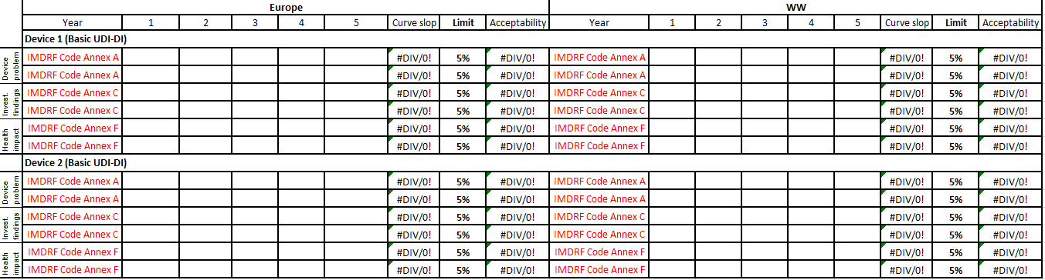

As represented in the next figure, any curve slope of trendline beyond 0.05 (5%) will be considered significant. For the same trendline, one statistically significant increase will be determined as an anomaly and two consecutive statistically significant increases (i.e., over two collection periods) will require corrective and/or preventive actions, except if duly justified.

Figure 2: Example of trend analysis

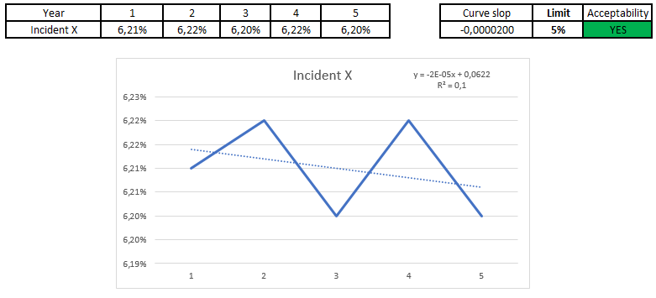

By derogation to the previous paragraph, no trend analysis can be performed for the first data collection period. Similarly, no accurate trendline can be delineated at the second data collection period. As a result, the rate reported beyond 0.1 (10%) as compared to the first data collection period will be evaluated significant. If this statistically significant increase is confirmed during the third data collection period, corrective and/or preventive actions will be required, except if duly justified.

As a result, the observation period of trends starts after two data collection periods, corrective and preventive actions may be defined and implemented after three data collection periods and then every year.

In addition, as long as the rates in severity or likelihood (i.e., thresholds) are within the limits defined in the risk management file (see **Section 4.1**), the benefit-risk ratio will not be considered affected. For any statistical increase beyond the thresholds defined in the risk management file, the trend will be justified for the impact on the benefit-risk ratio. Any negative impact on the benefit-risk ratio will require to be reported to the competent authorities according to Article 88 of the MDR.

# Equivalent / similar devices

The following products are equivalent or similar to [device short name].

Table 5: Equivalent and similar devices

| **Device Name** | **Manufacturer** | **Equivalent or Similar devices** |
| --- | --- | --- |
|  |  |  |
|  |  |  |
|  |  |  |
|  |  |  |

# PMS activities

PMS activities in scope of this PMS plan are described in the following table. As part of the PMS, a proactive post-market clinical follow-up has been defined under the PMCF plan: [Doc+rev].

Here is a proposal that needs to be customized as needed.

Table 6: PMS activities

| **PMS Activity** | **Description and methods** | **Outputs** |
| --- | --- | --- |
| Information concerning serious incidents | Collection of data:  The serious incidents resulting from complaints handling will be collected and analyzed by Basic UDI-DI/device model over several contiguous one-year periods. For every Basic UDI-DI, the incidents will be presented using the IMDRF Adverse Event Terminology by:   * Device problems (Annex A) * Root-cause (Annex C) * Health effect (Annex F)   Reference procedure (if applicable): XXXX | Assessment of data:  Justify how the data will be assessed in the PMCF Evaluation Report. |
| Information from Trend Reporting | Collection of data:  The non-serious incidents resulting from complaints handling will be collected and analyzed by Basic UDI-DI/device model over several contiguous one-year periods. For every Basic UDI-DI, the incidents will be presented using the IMDRF Adverse Event Terminology by:   * Device problems (Annex A) * Root-cause (Annex C) * Health effect (Annex F)   Reference procedure (if applicable): XXXX | Assessment of data:  Justify how the data will be assessed in the PMCF Evaluation Report. |
| Information from Field Safety Corrective Actions (FSCA) | Collection of data:  Any FSCA initiated, updated, closed during the PSUR period and in relation to the [device short name] will be documented including: type of actions, issuing date, scope, status, manufacturer reference number as well as brief description of actions, reason(s) for action and impacted regions.  Reference procedure (if applicable): XXXX | Assessment of data:  Justify how the data will be assessed in the PMCF Evaluation Report. |
| Preventive and / or Corrective Actions (CAPA) | Collection of data:  Any CAPA initiated, updated, closed during the PSUR period and in relation to the [device short name] will be documented including: type of actions, initiation date, scope, status of actions, root-cause, manufacturer reference number as well as CAPA description, and status of the CAPA (effective or not).  Reference procedure (if applicable): XXXX | Assessment of data:  Justify how the data will be assessed in the PMCF Evaluation Report. |
| ***General post-market clinical follow-up information*** | | |
| Feedbacks and complaints from users, distributors and importers | Collection of data:  All feedback from users, distributors and importers not reported in the complaint handling system, will be reviewed to determine if they meet the definition of incident under MDR and are related to [device short name].  Feedback that meets both criteria above will be classified by Device Problem according to IMDRF Adverse Event Terminology (Annex A) with the occurrence rate and the justification of data inclusion under this IMDRF code or data exclusion (when applicable). As a result, CAPA initiated following the feedback will be described.    Reference procedure (if applicable): XXXX | Assessment of data:  Justify how the data will be assessed in the PMCF Evaluation Report.  *Note: though MDCG2020-21 considers this activity under PMCF, [manufacturer short name] will conduct this review during PMS activities.* |
| Scientific Literature Review of relevant specialist or technical literature | Collection of data:  A literature search will be implemented as part of PMCF activities to detect the published articles related to the [device short name] and bring clinical evidence to confirm safety and performance of the device. The detailed information is described in PMCF plan.  Results of literature search implemented will be summarized to identify the key and other safety and performance parameters with the associated specifications. The data will be classified under articles on on-label or off-label /mis-use.  Reference procedure (if applicable): XXXX | Assessment of data:  Justify how the data will be assessed in the PMCF Evaluation Report. |
| Public Database | Collection of data:  A vigilance / recall search will be implemented as part of PMCF activities to detect any safety events reported for [device short name] and bring additional clinical evidence for the demonstration of safety and performance of the device. The detailed information is described in PMCF plan.  Results of vigilance and recall search implemented will be summarized to identify the device-related and patient-related risks.  Reference procedure (if applicable): XXXX | Assessment of data:  Justify how the data will be assessed in the PMCF Evaluation Report. |
| Public Registry Data | Collection of data:  A clinical trial search will be implemented as part of PMCF activities to detect the unpublished articles related to the [device short name] and bring clinical evidence to confirm safety and performance of the device. The detailed information is described in PMCF plan.  Results of clinical trial search implemented will be summarized to identify the key and other safety and performance parameters with the associated specifications. The data will be classified under articles on on-label or off-label /mis-use.  Reference procedure (if applicable): XXXX | Assessment of data:  Justify how the data will be assessed in the PMCF Evaluation Report. |
| **Post-market clinical follow-up information on equivalent or similar devices** | | |
| Scientific Literature Review of relevant specialist or technical literature | Collection of data:  A literature search will be implemented as part of PMCF activities to detect the published articles related to similar/equivalent devices and bring clinical evidence to confirm safety and performance acceptance criteria to evaluate the safety and performance of [device short name]. The detailed information is described in PMCF plan.  Reference procedure (if applicable): XXXX | Assessment of data:  Justify how the data will be assessed in the PMCF Evaluation Report. |
| Public Database | Collection of data:  A vigilance / recall search will be implemented as part of PMCF activities to detect any safety events reported for similar/equivalent devices. The search will bring additional clinical evidence to confirm safety and performance acceptance criteria to evaluate the safety and performance of [device short name]. The detailed information is described in PMCF plan.  Reference procedure (if applicable): XXXX | Assessment of data:  Justify how the data will be assessed in the PMCF Evaluation Report. |
| Public summary of safety and clinical performance  Only applicable to class III and implantable devices | Collection of data:  A review of safety and performance data published in the PSUR(s) of similar/equivalent devices will be reviewed to confirm the acceptance criteria for the evaluation of safety and performance of [device short name]. The detailed information is described in PMCF plan.  Reference procedure (if applicable): XXXX | Assessment of data:  Justify how the data will be assessed in the PMCF Evaluation Report. |
| ***Specific post-market clinical follow-up information*** | | |
| If no specific PMCF procedure is required, include a justification. Otherwise, remove the raw.  XXXX | | |
| Patient survey | Collection of data:  Results of patient survey for the data collection period will be documented to demonstrate how the objectives of the specific PMCF procedure are achieved and any findings resulting from the PMCF activity. This includes:   * Study type and objectives * Status * Results of survey * Risk identified * Findings and conclusion   Reference procedure (if applicable): XXXX | Assessment of data:  Justify how the data will be assessed in the PMCF Evaluation Report. |
| User survey | Collection of data:  Results of user survey for the data collection period will be documented to demonstrate how the objectives of the specific PMCF procedure, are achieved and any findings resulting from the PMCF activity. This includes:   * Study type and objectives * Status * Results of survey * Risk identified * Findings and conclusion   Reference procedure (if applicable): XXXX | Assessment of data:  Justify how the data will be assessed in the PMCF Evaluation Report. |
| Device registry | Collection of data:  Results of device registry consultation for the data collection period will be documented to demonstrate how the objectives of the specific PMCF procedure, are achieved and any findings resulting from the PMCF activity. This includes:   * Study type and objectives * Status * Results for key or other safety and performance parameters * Adverse events * Findings and conclusion   Reference procedure (if applicable): XXXX | Assessment of data:  Justify how the data will be assessed in the PMCF Evaluation Report. |
| PMCF investigation | Collection of data:  Results of PMCF investigation for the data collection period will be documented to demonstrate how the objectives of the specific PMCF procedure, are achieved and any findings resulting from the PMCF activity. This includes:   * Study type and objectives * Status * Results for key or other safety and performance parameters * Adverse events * Findings and conclusion   Reference procedure (if applicable): XXXX | Assessment of data:  Justify how the data will be assessed in the PMCF Evaluation Report. |

Remove the non-applicable specific procedures and methods of PMCF.

PMS activities as planned in **Section 6,** will be presented organized by Basic UDI-DI or device model.

# PMS methods

The following table describes the PMS methods and procedures used for the PMS plan of [device short name].

Table 7: PMS methods and procedures

| **Methods** | **Description / related Procedure** |
| --- | --- |
| PMS system | [Doc+rev.] indicate the QMS procedure |
| Collection and Assessment of available information | See Table above |
| Indicators and Threshold for continuous reassessment of B/R ratio | See Table above |
| Investigation of complaints | [Doc+rev.] indicate the QMS procedure |
| Incidents subject to the trend report | [Doc+rev.] indicate the QMS procedure |
| Evaluation of statistically significant increase in the frequency or severity of incidents and observation period | [Doc+rev.] indicate the QMS procedure |
| Communication with NB | [Doc+rev.] indicate the QMS procedure |
| Communication with CA | [Doc+rev.] indicate the QMS procedure |
| Communication with EO | [Doc+rev.] indicate the QMS procedure |
| CAPA process | [Doc+rev.] indicate the QMS procedure |
| Change control process | [Doc+rev.] indicate the QMS procedure |
| Traceability during field corrective actions | [Doc+rev.] indicate the QMS procedure |

# PMS report / PSUR

The results of the implementation of PMS plan will be documented in a PMS Report for class I devices/ PSUR for class IIa, IIb and III devices. Data will be collected, trended, analyzed to determine the need of product improvement, update of risk management activities and/or CAPAs as well as communication with the regulatory authorities (e.g., competent authorities) or notified body.

The PMS information will also be reviewed and incorporated into the following documentation:

* Risk Management File as part of the production and post-production information, refer to [Doc+rev.]
* Clinical Evaluation Report (CER), as the PMCF and PSUR results will feed the CER, refer to [Doc+rev.]
* Technical Documentation for compliance to Annex III of the MDR, refer to [Doc+rev.]
* Design history file for any change implemented, refer to [Doc+rev.]

Other documents can also be considered such as biological evaluation report and usability engineering file.

A Periodic Safety Update Report (PSUR) / PMS report will be issued every year as the device is class III/IIb / or every two years as the device is class IIa device / or every three/four years as the device is class I and XXX include a justification for the frequency of class I

# PMS schedule

The complete life-cycle of clinical/PMS activities is represented with the following pictures.

*Note: SSCP is only applicable for class III and implantable devices.*

Figure 3: Clinical/PMS life-cycle

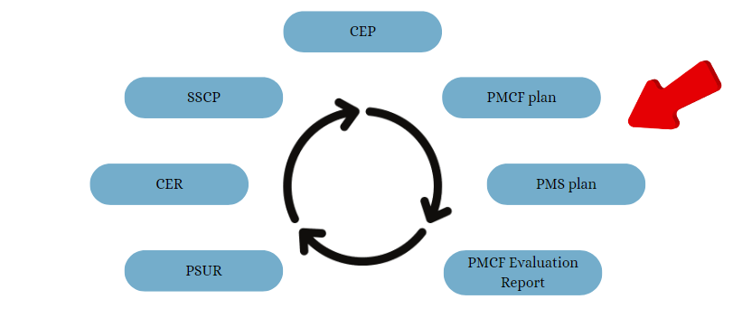

The following schedule has been defined for the PMS activities of [device short name]:

* PMCF Evaluation Report: DD-Mon-YYYY The schedule of PMCF activities can be more detailed if necessary
* PSUR/PMS report :
  + Collection period: from DD-Mon-YYYY to DD-Mon-YYYY
  + Analysis: from DD-Mon-YYYY to DD-Mon-YYYY
  + Submission to NB/in EUDAMED: DD-Mon-YYYY

# Appendix I – Devices in scope of PMS plan

| **Basic UDI-DI / EUDAMED-DI** | **Device trade name** | **Device description** | **UDI-DI** | **EMDN code** | **MDN / MDA code** | **Class** | **Lifetime** | **Certificate number** | **NB number** |
| --- | --- | --- | --- | --- | --- | --- | --- | --- | --- |
| **Leading device** | | | | | | | | | |
|  |  |  |  |  |  |  |  |  |  |
| **Other devices** | | | | | | | | | |
|  |  |  |  |  |  |  |  |  |  |
|  |  |  |  |  |  |  |  |  |  |
|  |  |  |  |  |  |  |  |  |  |